As a small to medium sized business owner in the service industry, generating leads is one of the most important aspects of growing your business. But with so many different marketing strategies and tactics out there, it can be overwhelming to know where to start. That's why we've put together this guide to help you generate leads today using tactics that are working in 2023.
- Use Social Media to Your Advantage
Social media is one of the most powerful tools for generating leads today. With billions of active users across multiple platforms, it's an excellent way to reach new audiences and connect with potential customers.
- The first step is to identify which platforms your target audience is most active on. For example, if you're targeting younger consumers, platforms like Instagram and TikTok may be the most effective. If you're targeting professionals, LinkedIn may be a better choice.
- Once you've identified your target platforms, start creating content that resonates with your audience. This could include educational blog posts, informative videos, or engaging social media posts that showcase your services. Make sure to include calls-to-action (CTAs) in your content that encourage people to learn more about your business or schedule a consultation.
- Focus on getting engagement on your social media posts. Use your content as a targeted topic conversation starter to attract your ideal clients to want to share a comment.

For example, as a business growth coach my target market are established business owners, Founders, CEO’s Presidents of service based businesses typically generating $300K/year to $30 Million a year in sales revenue. My clients are mostly using LinkedIn, so that’s where I focus my lead generation.

Here is an example of one of my LinkedIn posts:
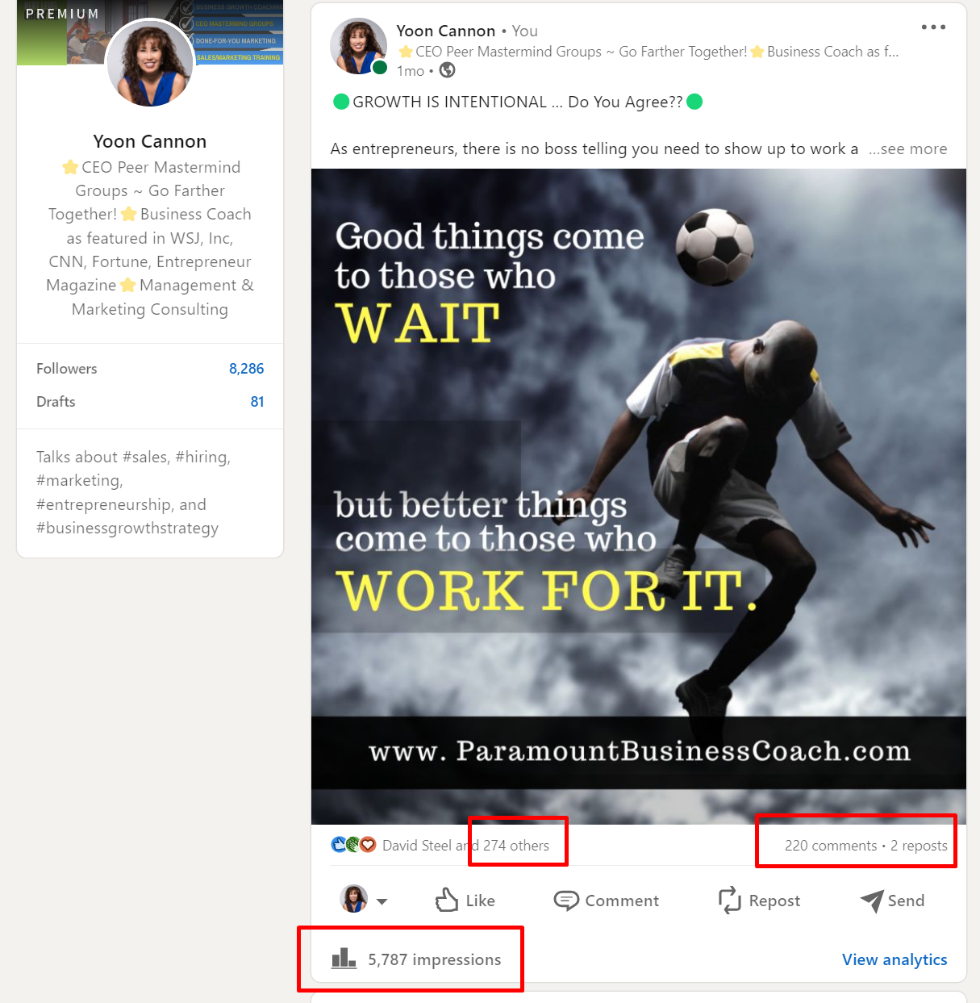

Once they like your post and/or share a comment your future posts will now get throttled out to their LinkedIn feed, so every time you post again on LinkedIn you get to stay top of mind to your growing network of LinkedIn connections.

BONUS TIP: You want to respond to the people who took the time to share a comment AND if they are your target market or a potential referral partner I would also send everyone who commented on your post a request to connect on LinkedIn, so that you grow your 1st degree connection network.
- Create Valuable Content
Creating valuable content is an effective way to generate leads. Content marketing is all about creating and sharing content that is relevant and valuable to your target audience. Here are some tips to help you get started with content marketing:
- Identify your target audience: To create content that resonates with your audience, you need to know who they are. Identify your target audience and create content that addresses their pain points, challenges, and interests.
- Use a variety of formats: Content can take many forms, including blog posts, videos, infographics, and social media posts. Use a variety of formats to keep your content fresh and engaging.
- Optimize your content for search engines: Make sure your content is optimized for search engines by using relevant keywords, meta tags, and descriptions. This will help your content rank higher in search engine results pages, making it more visible to potential leads.

Today, when it comes to lead generation - quality content is the new currency to attracting your ideal target market. In my experience working with SMB Owners however, I find most entrepreneurs get stuck on content ideas, or they don’t feel like they’re a good writer, or simply they don’t have the bandwidth to turn their knowledge and expertise into content.

If that’s you, the easiest solution could be to outsource your content creation, so you don’t need to add that project on your plate. Because this was a common barrier that held back many of my business coaching clients from executing their marketing, we started offering a la cart done-FOR-you marketing services.
RENT OUR MARKETING TEAM. Read more here: https://www.paramountbusinesscoach.com/membership/rent-our-marketing-team/
- Use Email Marketing
Email marketing is a tried and tested way to generate leads. It is a cost-effective way to reach a large audience and can be personalized to target specific segments of your audience. Here are some tips to help you get started with email marketing:
- Build your email list: The first step in email marketing is to build your email list. You can do this by offering a lead magnet such as a free e-book or webinar in exchange for an email address.
- Personalize your emails: Personalized emails have a higher open rate and click-through rate than generic emails. Use segmentation to send targeted emails to specific segments of your email list.
- Provide value: Make sure your emails provide value to your subscribers. This can include exclusive content, promotional offers, or helpful tips.
- Attend Networking Events
Networking events are a great way to meet potential leads in person. Whether it's a trade show, conference, or industry event, attending networking events can help you generate leads and build relationships. Here are some tips to help you get the most out of networking events:
- Be prepared: Before attending a networking event, research the attendees and prepare your elevator pitch. This will help you make a good impression and start conversations with potential leads.
- Collect contact information: Make sure you collect contact information from the people you meet. This can include business cards or email addresses.
- Follow up: After the event, follow up with the people you met. This can include sending a personalized email or connecting on LinkedIn.

RELATED ARTICLE: Top 3 Business Networking Mistakes. Read here:
https://www.paramountbusinesscoach.com/blog/top-3-business-networking-mistakes/
- Leverage the Power of Video
Video is quickly becoming the most popular type of content online, and for good reason. It's highly engaging and can be used to showcase your services in a way that's more compelling than text or images alone.
- Start by creating videos that highlight your services or demonstrate how they work. For example, if you're a massage therapist, you could create a video that shows the benefits of different types of massages or techniques you use.
- Once you've created your videos, share them on your website, social media channels, and YouTube.
- You can also use paid advertising on platforms like YouTube to reach a wider audience.
Here’s an example of one of my videos I published on YouTube. I simply invited 3 other SMB Owners to have a discussion where we share how we each sold our businesses to help other business owners who are thinking of selling their businesses.
[Embed video here] https://youtu.be/pIu1RA43EGg
Once I published it on YouTube, I also published it on our blog and on LinkedIn.

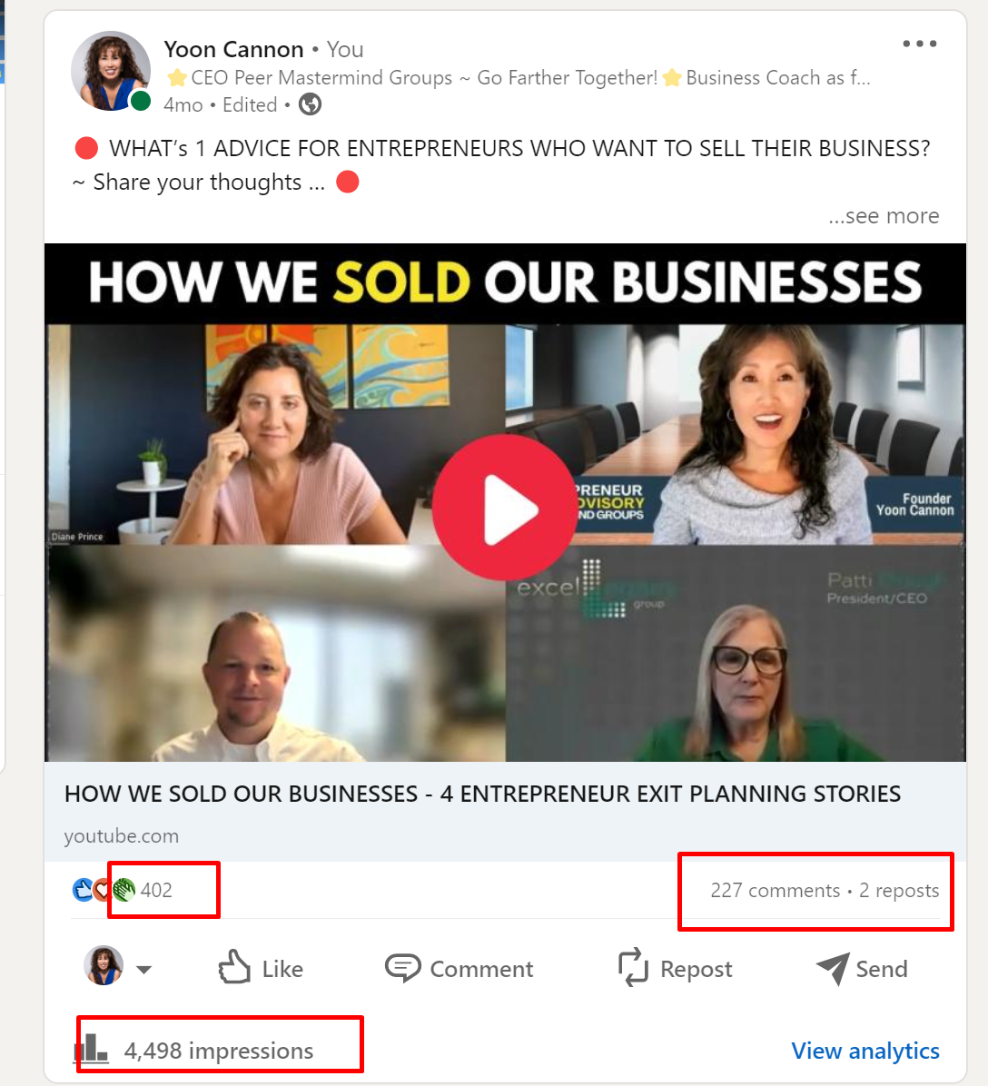
6. Invest in Search Engine Optimization (SEO)

Search engine optimization (SEO) is the process of optimizing your website to rank higher in search engine results pages (SERPs). This is important because the higher you rank, the more visible your business will be to potential customers.
- Start by identifying the keywords and phrases that people are using to search for services like yours.
- Then, optimize your website's content and structure to include these keywords in strategic places, such as the page title, headings, and meta descriptions.
- You can also improve your website's SEO by building backlinks from other reputable websites. This could include guest posting on other blogs, creating shareable infographics, or getting listed on local business directories.

WATCH MY FREE 23 MINUTE TRAINING ON SEO / DIGITAL MARKETING 101 Here: https://www.paramountbusinesscoach.com/marketing-mini-class-grow/
7. Offer Free Resources or Consultations
One of the most effective ways to generate leads today is by offering free resources or consultations. This could include a free cheat sheet, a free consultation, or a free trial of your services.
By offering something of value for free, you can attract potential customers who are interested in your services but may not be ready to make a purchase yet. This also gives you the opportunity to showcase your expertise and build trust with your audience.
Make sure to include clear CTAs in your free resources that encourage people to take the next step, whether that's scheduling a consultation or signing up for your newsletter.

For example, I offer 3 different free downloads on my website
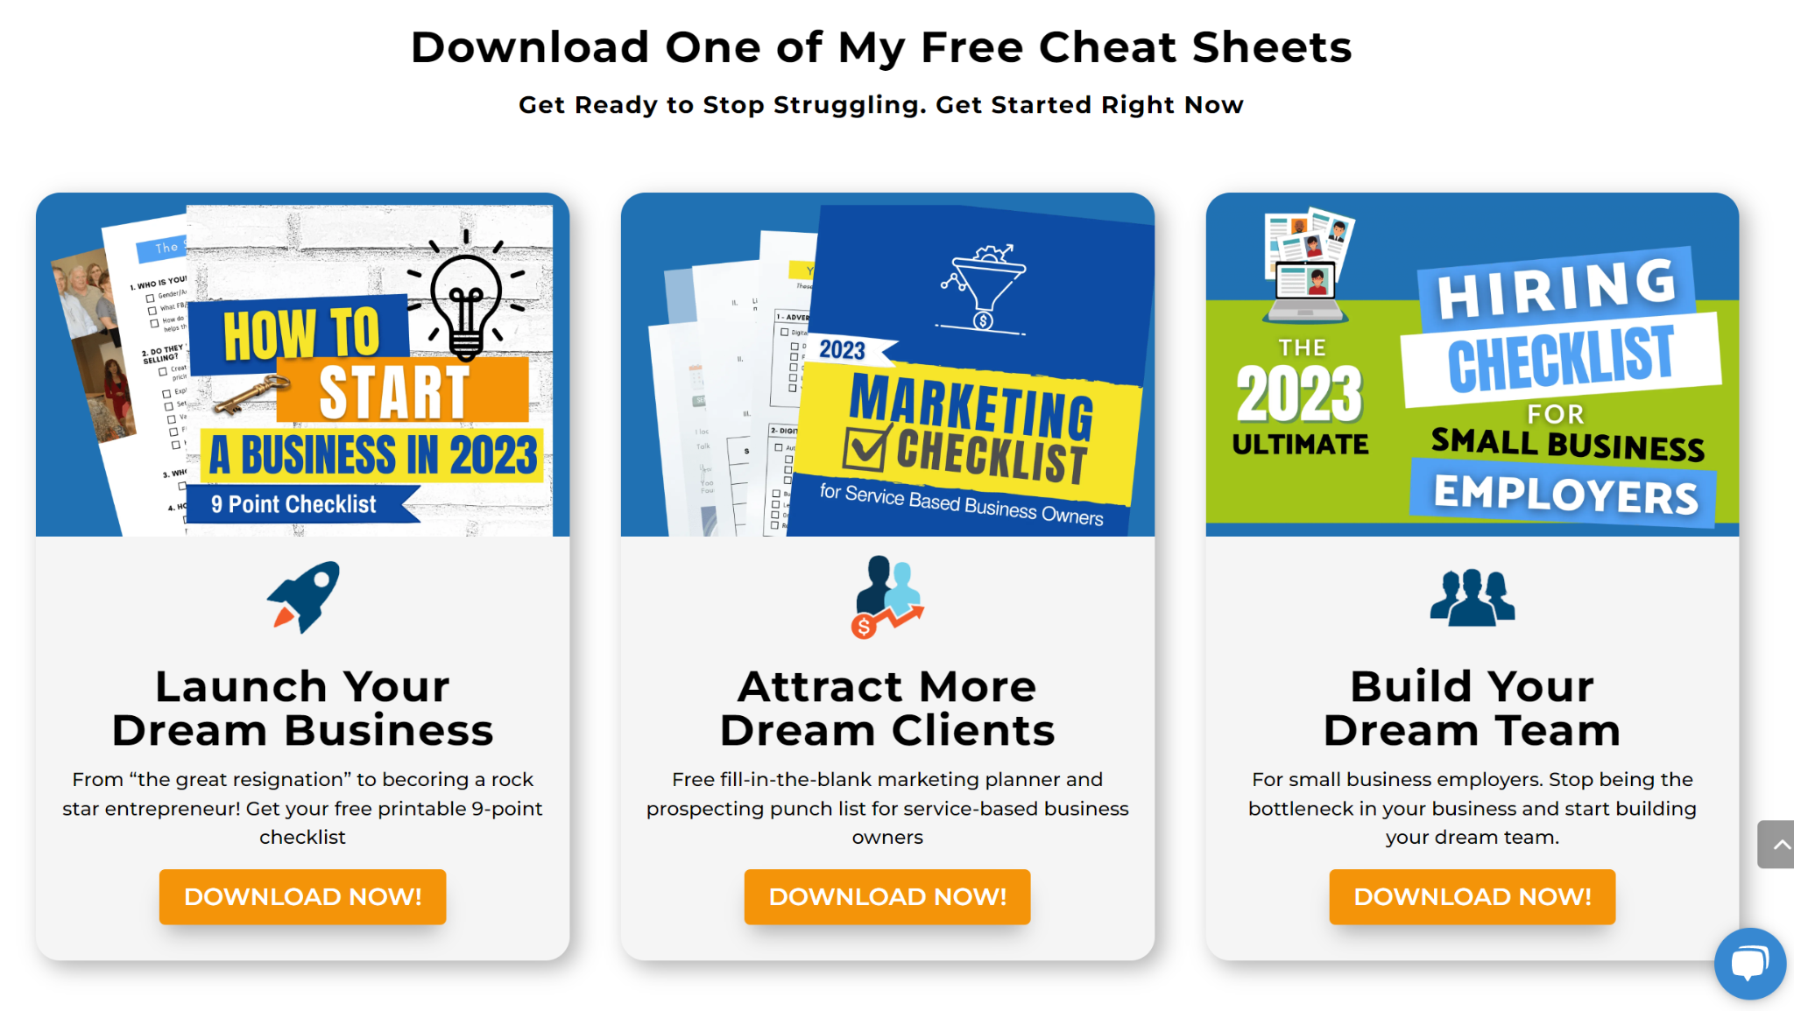

You can see each of the opt in pages here:
HOW TO START A BUSINESS ~ FREE CHECKLIST
MARKETING CHECKLIST FOR SERVICE BASED BUSINESS OWNERS
HIRING CHECKLIST FOR SMALL BUSINESS EMPLOYERS
8. Deliver Webinars to Generate Leads
Webinars are a powerful tool for generating leads and building brand awareness. A webinar is essentially an online seminar that can be presented in real-time or pre-recorded and streamed later. They are an effective way to educate prospects, establish authority, and convert leads into customers.
Here are some of the benefits of doing a webinar to generate leads:
- Cost-effective: Compared to traditional marketing methods, webinars are a cost-effective way to generate leads. They require minimal resources and can be conducted with just a few tools, such as a webcam, microphone, and internet connection.
- Increased engagement: Webinars allow you to interact with your audience in real-time, creating a more engaging experience. You can use polls, Q&A sessions, and live chat to keep your audience engaged and increase their participation.
- Demonstrates expertise: Hosting a webinar allows you to showcase your knowledge and expertise in your field. By providing valuable information to your audience, you can establish yourself as an authority in your industry, which can help to build trust and credibility.
- Builds relationships: Webinars provide an opportunity to build relationships with your audience by providing a platform for two-way communication. This can lead to increased loyalty and repeat business.
Getting started with a webinar is relatively easy. Here are the steps to follow:
- Choose a topic: The first step is to choose a topic that is relevant to your audience and aligns with your business goals. The topic should be focused and specific enough to attract the right audience.
- Set a date and time: Once you have chosen your topic, set a date and time that works for your target audience. Consider time zones, work schedules, and other factors that may impact attendance.
- Create the content: Develop a presentation that is informative, engaging, and visually appealing. Use slides, images, and videos to make your presentation more interesting.
- Promote your webinar: Use social media, email marketing, and other channels to promote your webinar and build buzz. Encourage people to register in advance to ensure maximum attendance.
- Host the webinar: On the day of the webinar, make sure you have all the necessary equipment and technology to deliver a seamless presentation. Engage with your audience, answer their questions, and provide valuable information.
Webinars are an effective way to generate leads and build relationships with your audience. By following these simple steps, you can get started with your own webinar and start reaping the benefits.

Here is an example of one of my webinars on
HOW TO GENERATE MORE LEADS FOR YOUR BUSINESS

When you go to this webinar registration page you can see exactly what attendees can expect to learn: https://www.paramountbusinesscoach.com/How-to-Get-More-Leads-for-Your-Business-in-2023/
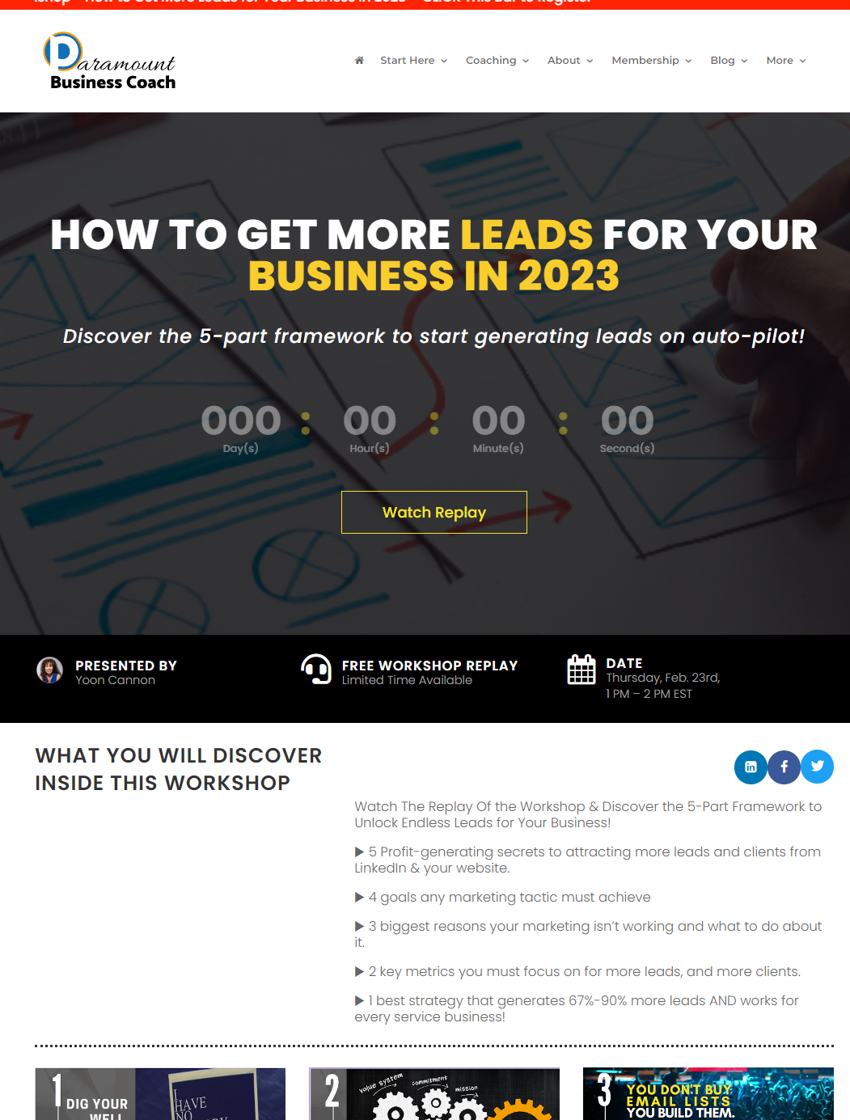

9. Pre-Qualify Your Lead Generation
Pre-qualifying leads is an essential part of any successful sales strategy. Pre-qualification is the process of identifying and evaluating potential customers before initiating the sales process.
This allows you and/or your sales teams to prioritize leads based on their likelihood to convert, thus saving time, resources, and effort. Here are some reasons why pre-qualifying your leads is important:
- Saves time and resources: Pre-qualifying leads helps to prioritize the most promising prospects and reduces the time spent on unqualified leads. This allows sales teams to focus on high-value prospects and allocate their resources more effectively.
- Improves conversion rates: By pre-qualifying leads, sales teams can identify prospects who are more likely to convert into customers. This allows them to tailor their approach and messaging to the specific needs and interests of each prospect, improving the chances of closing the deal.
- Reduces customer acquisition costs: Pre-qualifying leads can help to reduce customer acquisition costs by focusing efforts on the most promising prospects. This can help to improve the return on investment for marketing and sales activities.
- Enhances customer experience: By pre-qualifying leads, sales teams can better understand their needs, pain points, and goals. This allows them to tailor their approach and provide a more personalized customer experience, which can lead to higher customer satisfaction and loyalty.
There are several ways to pre-qualify leads, including:
- Lead scoring: This is a method of assigning a numerical value to each lead based on their characteristics and behavior. Leads are scored based on factors such as demographics, industry, budget, engagement level, and readiness to buy.
- Qualifying questions: These are questions designed to gather information about a lead’s needs, challenges, and budget. The answers to these questions can help to determine whether a lead is a good fit for your product or service.
- Sales development representatives (SDRs): SDRs are responsible for qualifying leads and setting appointments for sales teams. They can use a combination of lead scoring, qualifying questions, and research to pre-qualify leads and identify high-value prospects.
Pre-qualifying leads is an important step in any successful sales strategy. By identifying and evaluating potential customers before initiating the sales process, sales teams can prioritize their efforts, improve conversion rates, reduce costs, and enhance the customer experience.

Here is an example of how I pre-qualify my leads:
Business owners who are interested to learn more about working with me ~ whether they’re
- looking for a business coach,
- a peer Mastermind Group or whether they’re looking to
- outsource their marketing …
the calendar booking page I send them to is here:
https://www.paramountbusinesscoach.com/coaching/coaching-call-sign-up/
You’ll see before they can book a time slot, I tell them ahead of time, some basic pre-qualification filters:
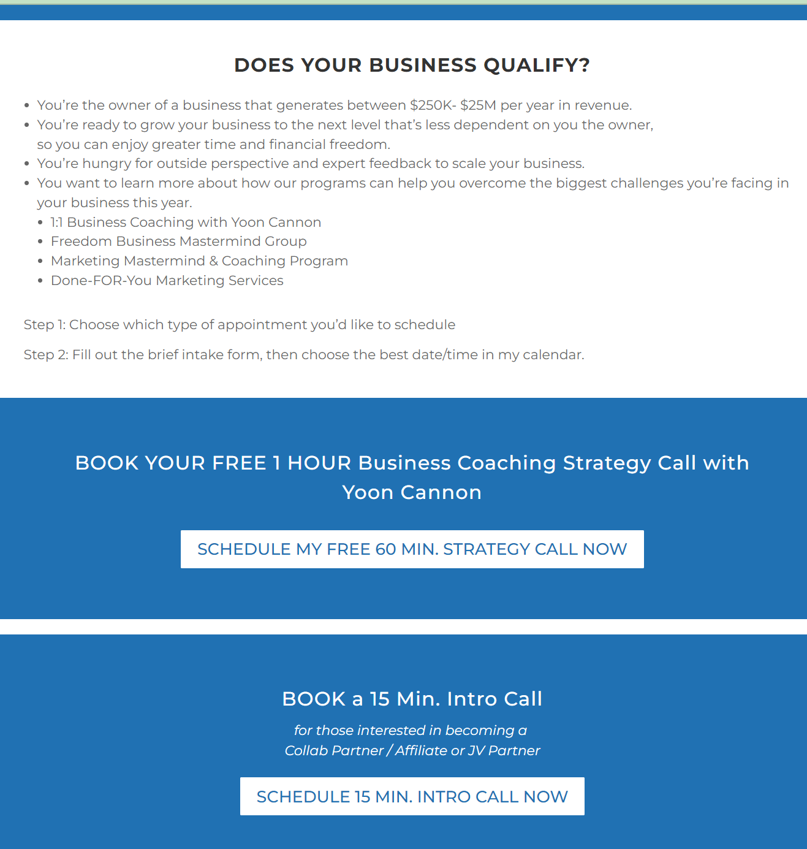

Generating leads is a crucial part of any successful marketing and sales strategy. To summarize in this article we covered nine ways to generate leads:
- Social media marketing
- Content marketing
- Email marketing
- Attending networking events
- Leveraging the power of vide
- SEO
- Offer FREE resources (aka ‘lead magnets’)
- Deliver webinars
- Pre-qualify your leads.

Generating leads requires a combination of tactics that can be tailored to your business goals and target audience. By leveraging a mix of content marketing, email marketing, social media marketing, paid advertising, referral marketing, events, webinars, SEO, and lead magnets, you can attract potential customers, build relationships, and move them closer to a sale.
QUESTION: Which of these 9 lead generation tactics are working the best for you in your business? Which of these do you need help with? Please share your comments or questions here



